DIFFERENTIATED LITERACY ACTIVITY
Activity Name:  CVC picture cards  Critical Aspect:  Phonics  Phonemic awareness  Outcome :  RES1.5 WES1.11  Indicator :  Can recognise initial sounds  Can rhyme words  Resources:  Picture cards of cvc words  Counters  Lego blocks  White board /markers, sound boxes | 1  Identify known initial sounds  Identify single lego blocks and match to picture cards.  Eg gun-g  fox-f  model rhyming with cvc words  Does gun rhyme with sun?  Does fox rhyme with gun?  Does fox rhyme with box?  Make these using lego blocks to see one to one correspondence on rime. | 2  Collect all pictures which begin with the same sound.  Place together with the sound card.  Make words with blocks.
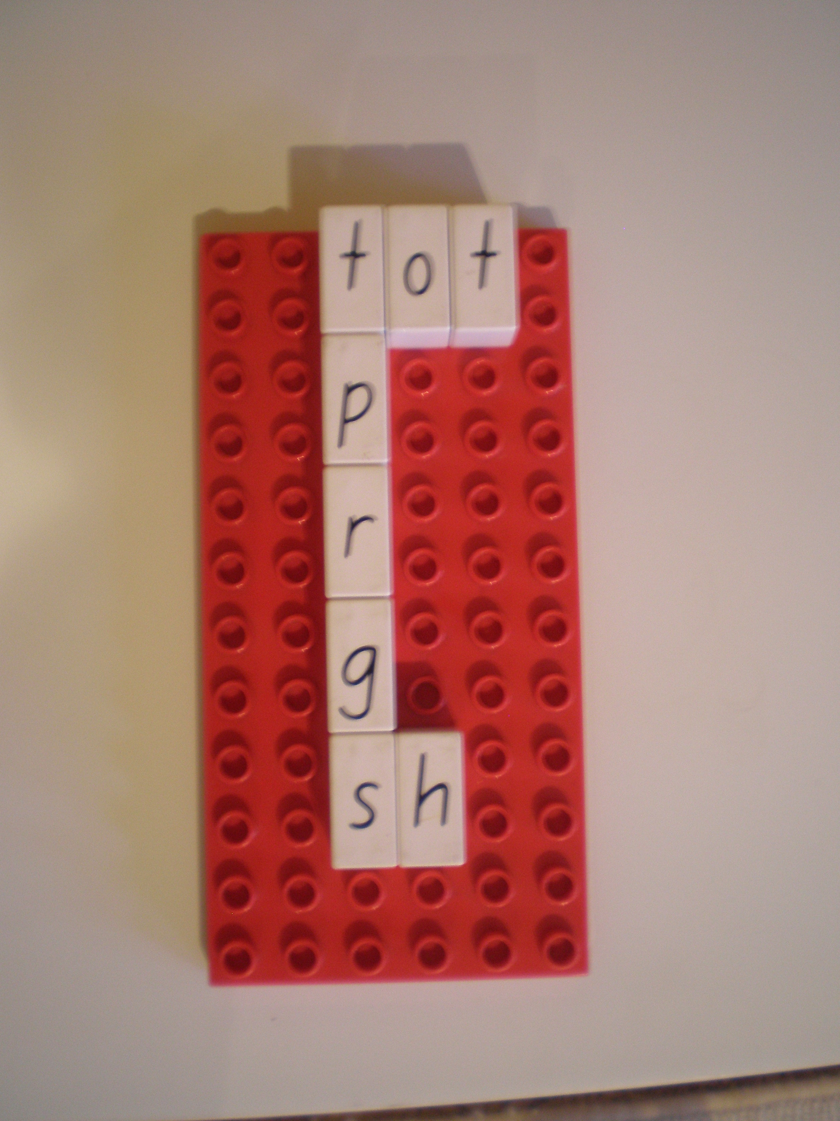 | 3  Use lego blocks in sound boxes to make the words on picture cards.  fox,pin,gun | 4  Find two words which rhyme from the selection and write these pairs on a white board. Check spelling using a picture dictionary/or spell check.

