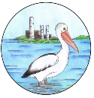
Mannering Park Public School Wellbeing Lesson overview
Term 3
Objective
The purpose of these lessons is to support students and staff to become familiar with the Mannering Park Public School’s new school rules:
A Respectful Learner
A Responsible Learner
A Safe Learner
Lessons will continuously refer to the Mannering Park Public School’s Behaviour Expectations matrix:
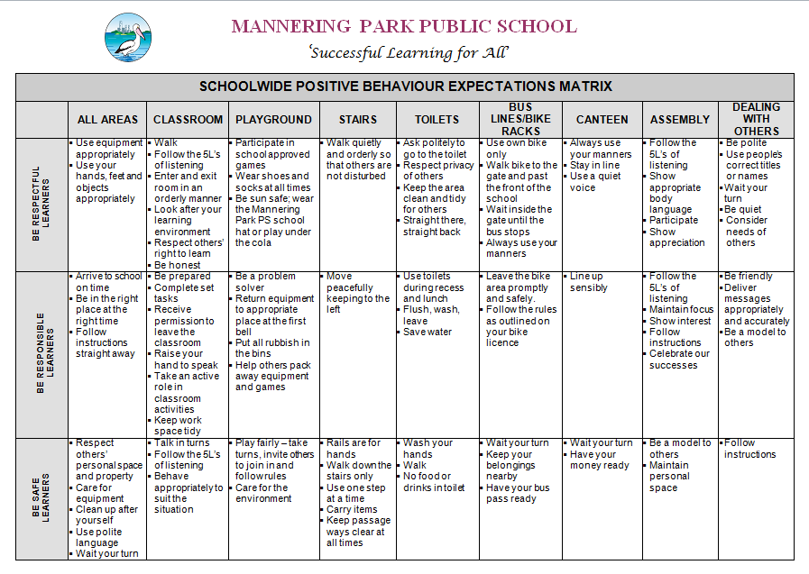
Implementation
Lessons are designed to be implemented once a week to ensure consistency across the school in the language being used and to ensure students and teachers have the same positive behaviour expectations across the school.

Term 3 lessons

Week | Lesson | Page +Number
4 | Assembly | 3
5 | Concert Rehearsal | 5
6 | Hats | 7
7 | Toilets | 9
8 | Going out of bounds | 11
9 | Inappropriate play on quad | 13
10 | Assembly of excellence | 15

Mannering Park PS Wellbeing Lesson
For: Assembly
I AM:
A Respectful Learner
A Responsible Learner
A Safe Learner

Assembly Expectations:
- We walk to and from the hall in lines quietly
- We sit down in our class lines
- We leave room for everyone to sit down in our class lines with our legs crossed
- We sit and wait quietly for assembly to begin
- We show our 5L’s of listening
- At the end of each item we clap politely (no yahooing)
- We participate in assembly activities responsibly

TEACHING EXAMPLES:
EXAMPLE: Jenny walks silently in and sits down, leaving enough space for the people near her to sit comfortable and she uses her 5L’s of listening and claps politely.

NON EXAMPLE: Grace walks in talking, sits down touching others she yells out comments and talks during the presentations

EXAMPLE: The junior dancers have completed a performance and turns and walks silently back to their position while the audience applaud appropriately and sit and wait quietly for the next speaker to begin.
STUDENT ACTIVITY
- Discuss the 3 scenarios.
- Role play entering, sitting in class lines appropriately and leaving the hall
- Review the words to the national anthem and the school pledge. Practice standing and sitting after
- Role play the correct procedure for receiving an award

REINFORCEMENT
- Positive praise “I like the way you….” (see assembly expectations).
- Magnificent Mannys before, during and after assembly
- Assembly awards – state reasons for receiving awards (refer back to expectations)
- Behaviour choices eg, your choices are: If you continue to ________, you will _____________ (set consequence) or you can ________(expected behaviour) and you will be able to _______(reward)

Assembly Behaviour
CHECKLIST
We will: | Teaching Points | Teach | Practice | Pre-Correct | Revise
Be Respectful Learners | - Wait patiently for assembly to begin  - Remain seated until you are asked to stand  - Stand quietly with your hands by your side or behind you back  - Wait quietly between assembly items  - Clap in an appropriate manner after each item or speaker if required  - Follow 5L’s when seated  - Accept your award with a firm hand shake, a smile and a polite “Thank you”  - Display your award with pride while standing tall on your grade step
Be Responsible Learners | - Participate sensibly  - Be a polite and attentive audience member  - Keep your hands and feet to yourself
Be Safe Learners | - Enter and exit the hall sensibly and quietly  - Be aware of your surroundings, other people, steps, stage cords  - Ensure an isle is left for safe movement

Mannering Park PS Wellbeing Lesson
For: Concert Rehearsal
I AM:
A Respectful Learner
A Responsible Learner
A Safe Learner

Rehearsal Expectations:
- We walk to and from the hall in lines quietly
- We sit down in our class lines
- We leave room for everyone to sit down in our class lines with our legs crossed
- We sit and wait quietly for rehearsal to begin
- We show our 5L’s of listening
- At the end of each item we clap politely (no yahooing)
- We participate in items responsibly

TEACHING EXAMPLES:
EXAMPLE: Jenny walks silently in and sits down, leaving enough space for the people near her to sit comfortable and she uses her 5L’s of listening and claps politely.

NON EXAMPLE: Sarah walks in talking, sits down touching others she yells out comments and talks during the performances

EXAMPLE: Year 3 have completed a performance and turns and walks silently back to their position while the audience applaud appropriately and sit and wait quietly for the next performance to begin.
STUDENT ACTIVITY
- Discuss the 3 scenarios.
- Role play entering, sitting in class lines appropriately and leaving the hall

REINFORCEMENT
- Positive praise “I like the way you….” (see assembly expectations).
- Magnificent Mannys before, during and after assembly
- Behaviour choices eg, your choices are: If you continue to ________, you will _____________ (set consequence) or you can ________(expected behaviour) and you will be able to _______(reward/praise)

Appropriate behaviour during concert rehearsal
CHECKLIST
We will: | Teaching Points | Teach | Practice | Pre-Correct | Revise
Be Respectful Learners | - Wait patiently for rehearsal to begin  - Remain seated until you are asked to stand  - Stand quietly with your hands by your side or behind you back  - Wait quietly between items  - Clap in an appropriate manner after each item or speaker if required  - Follow 5L’s when seated
Be Responsible Learners | - Participate sensibly  - Be a polite and attentive audience member  - Keep your hands and feet to yourself
Be Safe Learners | - Enter and exit the hall sensibly and quietly  - Be aware of your surroundings, other people, steps, stage cords  - Ensure an isle is left for safe movement

Mannering Park PS Wellbeing Lesson
For: Hats
I AM:
A Respectful Learner
A Responsible Learner
A Safe Learner

Lesson Objective: To be sun safe and wear Mannering Park PS hat.

TEACHING EXAMPLES:
Scenario 1. Sebastian is playing football and his hat constantly falls off. He then quickly puts it back on his head and continues playing so he doesn’t get sunburnt.

Scenario 2. Pippa forgets her hat and goes to play on the oval where she gets sunburnt.

Scenario 3. Raquel forgets her hat and plays handball under the COLA.

Scenario 4. Oscar has lost his hat and can’t find it.

STUDENT ACTIVITY
- Discuss the 4 scenarios.
- List reasons why we need to wear a hat in the playground.
- Role play
- Class contract- picture, statement

REINFORCEMENT
- Positive praise “I like the way you are sun safe by wearing your school hat/ playing under the COLA”.
- Magnificent Mannys
- Remind students to take their hats out during lunch and recess.
- Behaviour choices eg, your choices are: If you continue to ________, you will _____________ (set consequence) or you can ________(expected behaviour) and you will be able to _______(reward)

To be sun safe and wear Mannering Park PS hat
CHECKLIST
We will: | Teaching Points | Teach | Practice | Pre-Correct | Revise
Be Respectful Learners | - Wear your hats at recess and lunch  - Wear your hat during outdoor activities  - Hats are not play equipment – wear them sensibly  - Wear your hat correctly
Be Responsible Learners | - Leave your hat in your tray – do not take them home  - After playtime, out your hat away in your tray so it is safe  - Play under the quad if you do not have a hat  - Wear your hat correctly
Be Safe Learners | - Keep your hat on your head when you are outside

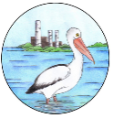
Mannering Park PS Wellbeing Lesson
For Toilets
I AM:
A Respectful Learner
A Responsible Learner
A Safe Learner

Lesson Objective: Using the toilets responsibly.

TEACHING EXAMPLES:
Example: During lunch breaks Bob uses the toilets sensibly, washes his hands and walks quickly out to play.

Non-Example: Michael pushes James into the toilet building, holds the door so James cannot leave. James throws the toilet roll in the toilet and wet toilet paper all over the ceiling; he urinates on the floor and sprays water on other students. His friends are laughing and won’t let him out of the door so he attempts to climb out of the window.

Example: Jasmine speaks kindly to other students while in the toilet area and returns to her friends who are playing football.

STUDENT ACTIVITY
- Discuss the Toilet Time poster.
- Discuss what appropriate toilet area behaviour looks like, sounds like and why it is important.
- Design a class poster from a relevant point below. Vote on whose class poster should be laminated and displayed in the toilet area.
Looks Like | Sounds Like
Students entering the area quickly and quietly  Students respecting the personal space of others  Close the toilet door  Wash your hands  Keep water in the sink  Allow people their privacy  Students use a sensible amount of toilet paper when required and place it in the toilet when finished, then flush  Place rubbish in the bin  Leave the toilet area quickly and quietly | Low level voices  Flush of the toilet  Tap running while hands are being washed and then being turned off when finished  Report all problems to teachers on duty

REINFORCEMENT
- Positive praise “I like the way you….” (refer to language use on the matrix)
- Magnificent Mannys
- Refer to the poster daily, before transitions.
- Behaviour choices eg, your choices are: If you continue to ________, you will _____________ (set consequence) or you can ________(expected behaviour) and you will be able to _______(reward)
Using the toilets responsibly
CHECKLIST
We will: | Teaching Points | Teach | Practice | Pre-Correct | Revise
Be Respectful Learners | - Use toilets during recess and lunch  - Flush, wash, leave  - Save water
Be Responsible Learners | - Ask politely to go to the toilet  - Respect privacy of others  - Keep the area clean and tidy for others  - Straight there, straight back
Be Safe Learners | - Wash your hands  - Walk  - No food or drinks in toilet

Mannering Park PS Wellbeing Lesson
For Going Out of Bounds
I AM:
A Respectful Learner
A Responsible Learner
A Safe Learner

Lesson Objective: Staying in Safe Play Areas

TEACHING EXAMPLES:
Example: Daniel left class at Recess and walked safely to a play area. He walked through the red line and kept going to a safe play area.

Non-Example: Sally ran and hid behind ½H (near the garden) at the start of lunch.

Example: Joe saw the red Out Of Bounds (OOB) line and kept walking to the playground.

Non-Example: Some children were running in an OOB area. They played chasings behind Kindergarten classrooms where the teacher could not see them.

STUDENT ACTIVITY
- Discuss rules for OOB as presented on the poster.
- Class walk to identify OOB areas.
- Identify what can happen if rules are not followed.

REINFORCEMENT
- Positive praise “I like the way you….” (refer to language use on the matrix)
- Magnificent Mannys
- Refer to the poster daily, before transitions.
- Behaviour choices eg, your choices are: If you continue to ________, you will _____________ (set consequence) or you can ________(expected behaviour) and you will be able to _______(reward)

Going Out of Bounds
CHECKLIST
We will: | Teaching Points | Teach | Practice | Pre-Correct | Revise
Be Respectful Learners | - Do not allow your friends to go out of bounds  - Listen to the teachers instructions if asked to leave an area
Be Responsible Learners | - Do not follow friends who go out of bounds  - If you see and Out of Bounds area sign, move away from that area  - Do not pass the red lines without teacher permission
Be Safe Learners | - Play where a teacher can see you  - Stay in the correct play areas  - Move safely to and from play areas

Mannering Park PS Wellbeing Lesson
For: Inappropriate play on the quad
I AM:
A Respectful Learner
A Responsible Learner
A Safe Learner

Lesson Objective: To be safe and responsible when playing on the quad.

TEACHING EXAMPLES:
Scenario 1. Johnny saw Jack sitti8ng by himself, so he asked if he would like to play handball.

Scenario 2. Tom pegged a ball and hit someone in the head.

Scenario 3. Dianne and her friends forgot their hats so they were reading quietly under the COLA.

Scenario 4. Ann and Gail were playing tips under the COLA .

STUDENT ACTIVITY
- Discuss rules for playing under the COLA.
- List safe and unsafe situations which occur under the COLA.
- Role play
- Students design posters displaying correct behaviour/choices being made under the COLA. Posters from each class will be displayed.

REINFORCEMENT
- Positive praise “I like the way you are playing safely with your friends under the COLA”.
- Refer to posters regularly.
- Magnificent Manny’s

Inappropriate play on the quad
CHECKLIST
We will: | Teaching Points | Teach | Practice | Pre-Correct | Revise
Be Respectful Learners | - Do not allow your friends to go out of bounds  - Listen to the teachers instructions if asked to leave an area
Be Responsible Learners | - Do not follow friends who go out of bounds  - If you see and Out of Bounds area sign, move away from that area  - Do not pass the red lines without teacher permission
Be Safe Learners | - Play where a teacher can see you  - Stay in the correct play areas  - Move safely to and from play areas

Mannering Park PS Wellbeing Lesson
For: Assembly of Excellence
I AM:
A Respectful Learner
A Responsible Learner
A Safe Learner

Lesson Objective: Students to sit and listen respectfully, listen to the assembly and watch students receive their rewards

TEACHING EXAMPLES:
Role Play Examples-
- Christopher walks silently I and sits down leaving enough space for the people near her to sit comfortably. He listens and claps politely. No Yahooing.

- Grace walks in talking, she sits down touching others. She yells out comments and talks during presentations
STUDENT ACTIVITY
- Discuss assembly of excellence manners and why is important
- Discuss and practise ‘personal body space.’
- Practise / role play personal body space when lining up, sitting in the hall.
- Practice walking on stage, shaking hands, and standing proudly with their awards. Practice walking silently and sensibly back to their spot
- Discuss and practice clapping after each speaker. No yahooing
REINFORCEMENT
- Positive praise “I like the way you are lining up without touching anyone” (refer to language use on the matrix)
- Behaviour choices eg, your choices are: If you continue to ________, you will _____________ (set consequence) or you can ________(expected behaviour) and you will be able to _______(reward)
- Magnificent Mannys
- Refer to behaviour expectation Matrix

Assembly of Excellence Behaviour
CHECKLIST
We will: | Teaching Points | Teach | Practice | Pre-Correct | Revise
Be Respectful Learners | - Wait patiently for assembly to begin  - Remain seated until you are asked to stand  - Stand quietly with your hands by your side or behind you back  - Wait quietly between assembly items  - Clap in an appropriate manner after each item or speaker if required  - Follow 5L’s when seated  - Accept your award with a firm hand shake, a smile and a polite “Thank you”  - Display your award with pride while standing tall on your grade step
Be Responsible Learners | - Participate sensibly  - Be a polite and attentive audience member  - Keep your hands and feet to yourself
Be Safe Learners | - Enter and exit the hall sensibly and quietly  - Be aware of your surroundings, other people, steps, stage cords  - Ensure an isle is left for safe movement

