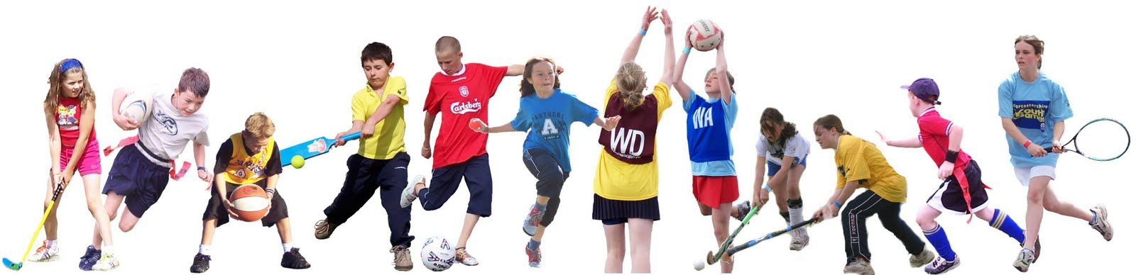

Stage 2 Sport Term 3 and 4
Objective
This sport program aims to assist in the development of fundamental movement skills and motor skills towards ensuring lifelong involvement in physical activity.
Outcomes
MOS2.4 Displays a focus on quality of movement in applying movement skills in a variety of familiar and new situations
ALS2.6 Discusses the relationship between regular physical activity and health
GSS2.8 Participates and uses equipment in a variety of games and modified sports
PHS2.12 Discusses the factors influencing personal health choices

Stage 2 will participate in 3 sporting activities developing a range of fundamental skills, locomotor skills, manipulative skills and game skills and strategies. Each group will participate in an activity for 5 weeks to gain a deep understanding of the game and the skills required.
 | Term 3 | Term 4
ACTIVITY | Weeks 4 - 9 | Weeks 1 - 5 | Weeks 6 - 10
T-ball (Andrew) | Red | Green | Blue
Netball (Leanne/Deb) | Blue | Red | Green
Volleyball (Courtenay) | Green | Blue | Red

