Category | 0 | 1 | 2 | 3 | 4 | 5 | 6
Text Structure
Structure (Imaginative) | No evidence of  any structural components of an imaginative text. | Minimal evidence of  structure. May not contain all three parts (orientation, complication, resolution) | Contains a beginning and  a complication. Resolution is present but weak. | Contains all three  structures and includes several complications AND/OR ideas. Uses plot devices. | Coherent, controlled and  complete narrative. Employs effective plot devices.
Structure (Informative) | No evidence of any structural components of an informative text | Minimal evidence of informative structure. | Text contains two clearly  identifiable structural components OR all components are present but weak | Text contains an  introduction, a body and conclusion OR detailed longer text with two developed components and one weaker component. | Coherent, controlled and  complete information. All components are well developed.
Structure (Persuasive) | No evidence of any structural components of a persuasive text | Minimal evidence of persuasive structure. Structural components not clearly identifiable OR one component only, e.g. an introduction or body | Text contains two clearly identifiable structural components OR all components are present but weak | Text contains an introduction, a body and conclusion OR detailed longer text with two developed components and one weaker component | Coherent, controlled and complete arguments. All components are well developed. Introduction with clear position statement AND body with reasons and detailed supporting evidence  AND conclusion that reinforces the writer’s position
Purpose
Audience | Symbols or | Response to | Shows basic awareness | Internally consistent text | Supports reader | Supports, engages/informs/ | Controls writer/reader
 | drawings which may have the intention of conveying | audience needs is limited. Contains some simple written content. Text is very | of audience expectations  through attempting to  orient the reader. Provides some info to | that attempts to support the reader by developing a shared understanding of context – i.e. contains | understanding and attempts  to engage/inform/  persuade the reader. | persuades the reader through deliberate language choices and techniques | relationship. Establishes  strong, credible voice.  Crafts writing to influence reader by precise and
 | meaning | short or difficult to | support reader | sufficient information for |  |  | sustained language
 |  | make any meaning | understanding. Text is | the reader to follow the |  |  | choices and techniques.
 |  | from. | short but easily read. | text easily |  |  | Takes readers’ values and
 |  |  |  |  |  |  | expectations into account
Ideas | No evidence or insufficient evidence | Text contains one  idea  OR ideas appear  unrelated to each other OR ideas are unrelated to topic on prompt | One idea with simple  elaboration OR ideas are few and related but not elaborated OR many simple ideas that are related but not elaborated | Ideas are supported with  some elaboration OR many unelaborated ideas that relate plausibly (4 or more) OR one idea with more developed elaboration | Ideas are elaborated and  contribute effectively to the writer’s position. Ideas may be elaborated by playing one side against the other, a refutation of other positions or opinions, explaining cause and effect | Ideas are generated, selected  and crafted to be highly engaging, informative or persuasive. Ideas may be elaborated by playing one side against the other, a refutation of other positions or opinions, explaining cause and effect

Category | 0 | 1 | 2 | 3 | 4 | 5 | 6
Devices (Imaginative) | Symbols or drawings that attempt to convey meaning. | Only names  characters or gives their roles. Only names the setting. No other devices. | Brief description of a  character and setting but lacks consistency. | Characterisation emerges  through descriptions, actions or speech. Setting emerges through description of place and time. | Details of characters are  selected to create realistic characters. Maintains are setting throughout.
Devices (Informative) | Symbols or drawings that attempt to convey meaning. | Graphics, pictures,  tables, and charts,  etc. if present are simple and unnecessary to understanding the text | Some correct use of  technical language.  Graphic, pictures, tables, and charts, etc are present and are mostly supplementary to understanding the text | Use of technical language  is integral to the text.  Graphics support or are integral to understanding the text. | Technical language is used  to enhance understanding.  Graphics are intricate, extensive and are integral to making meaning of the text; may provide information not otherwise conveyed in the text
Devices (Persuasive) | Symbols or drawings that attempt to convey meaning. | Uses a statement or  statements of  personal opinion AND/OR uses one or two instances of devices | Uses three or more  instances of persuasive  devices that support the writer’s position but do not  persuade the reader (at least two types) | Uses some devices that  persuade. Use is effective  but not sustained (may also include some ineffective use) | Sustained and effective use  of persuasive devices.  Effective devices are appropriate to style of argument and may appeal to one or more of the reader’s reason, values or emotions
Language Features
Vocabulary | Symbols or drawings | Very short script | Mostly simple verbs, adverbs, adjective or nouns and / or 2-3 precise words or word groups e.g, simple noun or verb groups | 4 or more precise words or word groups | Sustained and consistent use of precise words and word groups that enhance meaning (may be some inaccurate or inappropriate word groups) | A range of precise and effective words and word groups used in a fluent and articulate manner. Language use is well matched to style.
Cohesion | Symbols or drawings | Links are missing or incorrect. Short script. Often confusing for the reader | Some correct links between sentences and most referring words are accurate. Reader may need to re-read to clarify meaning. | Controlled use of cohesive  devices support reader understanding. Meaning is clear on first reading and text flows well in a sustained piece of writing | A range of cohesive devices  is used correctly and deliberately to enhance reading and support underlying relationship. An extended, highly cohesive piece of writing showing continuity of ideas and tightly linked sections of text

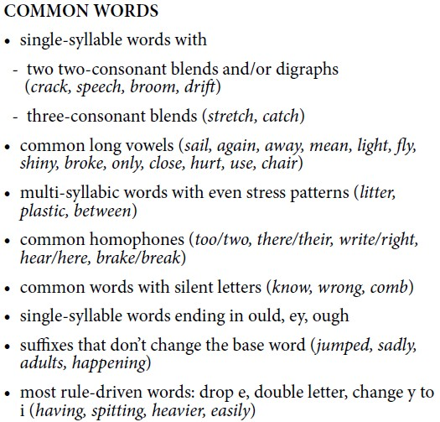
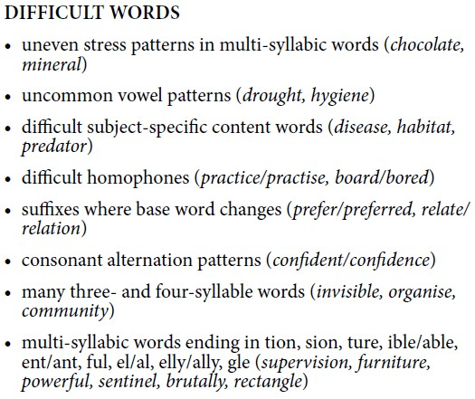
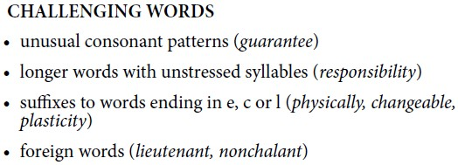

Category | 0 | 1 | 2 | 3 | 4 | 5 | 6
Para- graphing | No use of paragraphing / beginning sense | Writing is organised into paragraphs mainly focused on a single idea | All paragraphs are  focused on one idea or set of like ideas. At least one paragraph is logically constructed and contains a topic sentence and supporting detail paragraphs are correct but basic | Paragraphs are ordered  and cumulatively build ideas across text
Sentence Structure | No evidence of sentences | Some correct formation of sentences | Most simple sentences are correct | Most simple and compound sentences are correct and some complex sentences are correct. Meaning is predominantly clear. | Simple and compound sentences are correct and most complex sentences are correct. Meaning is clear. | Sentences correct. Demonstrates variety. Meaning is clear and sentences enhance meaning. | All sentences are correct.  Writing contains controlled and well- developed sentences that express precise meaning and are consistently effective
Punctuation | No evidence of correct punctuation | Some use of capital letters to start OR full stops at end | Some accurately punctuated sentences – at least 2, OR one correct sentence and one other appropriate punctuation mark | Sentence level  punctuation mostly correct (minimum of 80% of 5 sentences  punctuated correctly) AND some other correct punctuation (two or more examples of different types of other punctuation) | All sentence punctuation correct. Mostly correct use of other punctuation | Writing contains accurate use of all applicable punctuation. A wide variety of punctuation is used correctly including direct speech, ; :
Spelling | No conventional spelling | Few examples of conventional spelling | Correct spelling of most simple words and some common words | Correct spelling of most simple words and most common words | Correct spelling of simple words, most common words, some difficult words | Correct spelling of simple words, most common words, at least 10 difficult | Correct spelling of all words, 10+ difficult ones some challenging words

